

**COMSATS UNIVERSITY ISLAMABAD, LAHORE CAMPUS**

**Project Name:**

**Bus Ticket Booking System**

**Subject:**

**Object Oriented Programing**

**Submitted to:**

**Sir Shahid Bhatti**

**Submitted by:**

**HAMDAN ZULFIQAR – (SP24-BSE-032)**

**MUDDASAR ALI GHAFOOR – (SP24-BSE-062)**

**Submission Date: December 13, 2024**

**Login Page:**

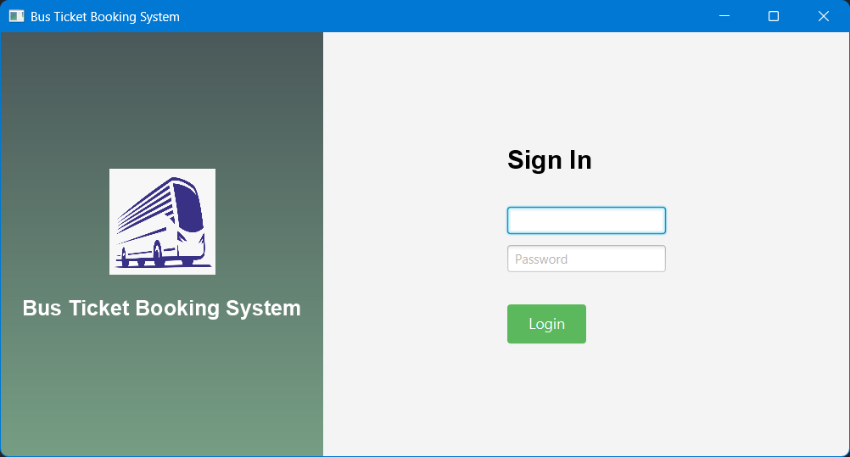

**Login page for login to Bus Ticket Booking System Application. This page requires a username and password to login to the dashboard of the application.**

**Dashboard Page:**

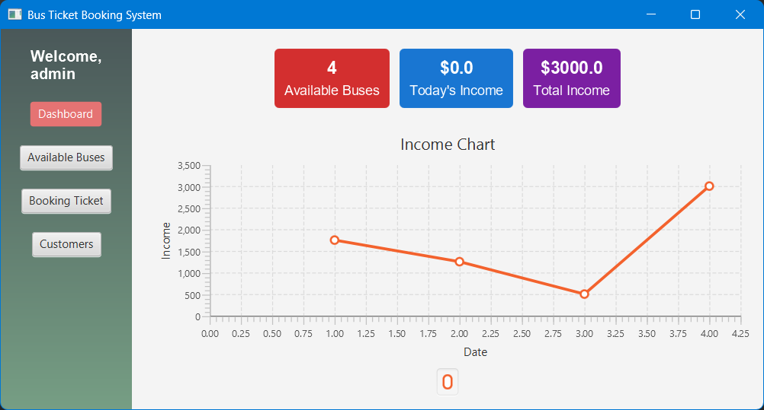

**This is the dashboard page of Bus Ticket Booking System Application. This page shows the number of available buses, total income for the present day, and the total income of the month. This page also show a chart for income details.**

**Available Buses Page:**

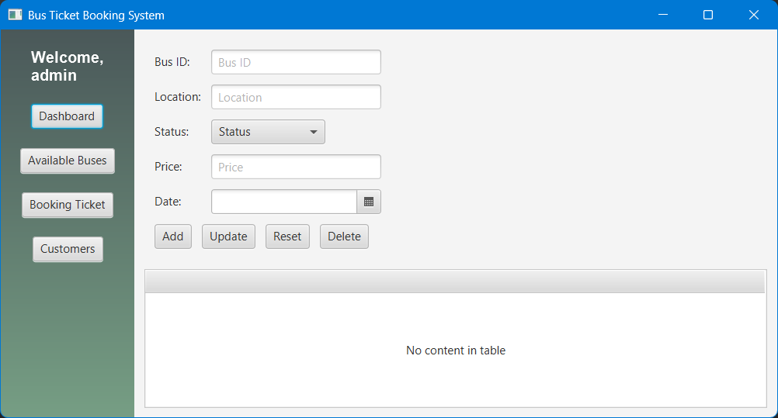

**This page shows the number of available buses and adds new buses data. It has two sections, one for the adding new buses details and the other one for the preview of already available buses.**

**Code:**

*import* javafx.application.Application;  
*import* javafx.geometry.Insets;  
*import* javafx.geometry.Pos;  
*import* javafx.scene.Scene;  
*import* javafx.scene.chart.LineChart;  
*import* javafx.scene.chart.NumberAxis;  
*import* javafx.scene.chart.XYChart;  
*import* javafx.scene.control.*;  
*import* javafx.scene.image.Image;  
*import* javafx.scene.image.ImageView;  
*import* javafx.scene.layout.*;  
*import* javafx.scene.text.Font;  
*import* javafx.scene.text.FontWeight;  
*import* javafx.scene.text.Text;  
*import* javafx.stage.Stage;  
  
*public class* LoginPage *extends* Application {  
  
 @Override  
 *public void* start(Stage primaryStage) {  
 *// Left side (Bus Ticket Booking System)* VBox leftPane = *new* VBox(20);  
 leftPane.setAlignment(Pos.CENTER);  
 leftPane.setStyle("-fx-background-color: linear-gradient(to bottom, #4A5859, #769E84);");  
 leftPane.setPadding(*new* Insets(20));  
  
 Image busIcon = *new* Image("bus.png"); *// Replace with an actual image path* ImageView busIconView = *new* ImageView(busIcon);  
 busIconView.setFitWidth(100);  
 busIconView.setFitHeight(100);  
  
 Text title = *new* Text("Bus Ticket Booking System");  
 title.setFont(Font.*font*("Arial", FontWeight.BOLD, 20));  
 title.setStyle("-fx-fill: white;");  
  
 leftPane.getChildren().addAll(busIconView, title);  
  
 *// Right side (Login Form)* GridPane rightPane = *new* GridPane();  
 rightPane.setAlignment(Pos.CENTER);  
 rightPane.setPadding(*new* Insets(20));  
 rightPane.setHgap(10);  
 rightPane.setVgap(10);  
  
 Text signInText = *new* Text("Sign In");  
 signInText.setFont(Font.*font*("Arial", FontWeight.BOLD, 24));  
  
 TextField usernameField = *new* TextField();  
 usernameField.setPromptText("Username");  
  
 PasswordField passwordField = *new* PasswordField();  
 passwordField.setPromptText("Password");  
  
 Button loginButton = *new* Button("Login");  
 loginButton.setStyle("-fx-background-color: #5CB85C; -fx-text-fill: white; -fx-font-size: 14px; -fx-padding: 8px 20px;");  
  
 rightPane.add(signInText, 0, 0, 2, 1);  
 rightPane.add(usernameField, 0, 1, 2, 1);  
 rightPane.add(passwordField, 0, 2, 2, 1);  
 rightPane.add(loginButton, 0, 3, 2, 1);  
  
 GridPane.*setMargin*(signInText, *new* Insets(0, 0, 20, 0));  
 GridPane.*setMargin*(loginButton, *new* Insets(20, 0, 0, 0));  
  
 *// Combine both sides* BorderPane root = *new* BorderPane();  
 root.setLeft(leftPane);  
 root.setCenter(rightPane);  
  
 Scene loginScene = *new* Scene(root, 800, 400);  
  
 *// Dashboard Scene* BorderPane dashboardRoot = createDashboard(primaryStage);  
 Scene dashboardScene = *new* Scene(dashboardRoot, 800, 400);  
  
 *// Login Button Action* loginButton.setOnAction(e -> primaryStage.setScene(dashboardScene));  
  
 primaryStage.setTitle("Bus Ticket Booking System");  
 primaryStage.setScene(loginScene);  
 primaryStage.show();  
 }  
  
 *private* BorderPane createDashboard(Stage primaryStage) {  
 *// Left navigation* VBox navPane = *new* VBox(20);  
 navPane.setAlignment(Pos.TOP_CENTER);  
 navPane.setStyle("-fx-background-color: linear-gradient(to bottom, #4A5859, #769E84);");  
 navPane.setPadding(*new* Insets(20));  
  
 Text welcomeText = *new* Text("Welcome,\nadmin");  
 welcomeText.setFont(Font.*font*("Arial", FontWeight.BOLD, 16));  
 welcomeText.setStyle("-fx-fill: white;");  
  
 Button dashboardButton = *new* Button("Dashboard");  
 Button busesButton = *new* Button("Available Buses");  
 Button ticketsButton = *new* Button("Booking Ticket");  
 Button customersButton = *new* Button("Customers");  
  
 dashboardButton.setStyle("-fx-background-color: #E57373; -fx-text-fill: white;");  
 navPane.getChildren().addAll(welcomeText, dashboardButton, busesButton, ticketsButton, customersButton);  
  
 *// Top statistics bar* HBox statsBar = *new* HBox(10);  
 statsBar.setPadding(*new* Insets(10));  
 statsBar.setAlignment(Pos.CENTER);  
  
 VBox availableBusesBox = createStatBox("4", "Available Buses", "#D32F2F");  
 VBox todaysIncomeBox = createStatBox("$0.0", "Today's Income", "#1976D2");  
 VBox totalIncomeBox = createStatBox("$3000.0", "Total Income", "#7B1FA2");  
  
 statsBar.getChildren().addAll(availableBusesBox, todaysIncomeBox, totalIncomeBox);  
  
 *// Income chart* LineChart<Number, Number> incomeChart = createIncomeChart();  
  
 VBox mainContent = *new* VBox(10, statsBar, incomeChart);  
 mainContent.setPadding(*new* Insets(10));  
  
 BorderPane dashboardRoot = *new* BorderPane();  
 dashboardRoot.setLeft(navPane);  
 dashboardRoot.setCenter(mainContent);  
  
 busesButton.setOnAction(e -> primaryStage.setScene(createAvailableBusesScene(primaryStage)));  
  
 *return* dashboardRoot;  
 }  
  
 *private* Scene createAvailableBusesScene(Stage primaryStage) {  
 BorderPane availableBusesRoot = *new* BorderPane();  
  
 *// Navigation Pane* VBox navPane = *new* VBox(20);  
 navPane.setAlignment(Pos.TOP_CENTER);  
 navPane.setStyle("-fx-background-color: linear-gradient(to bottom, #4A5859, #769E84);");  
 navPane.setPadding(*new* Insets(20));  
  
 Text welcomeText = *new* Text("Welcome,\nadmin");  
 welcomeText.setFont(Font.*font*("Arial", FontWeight.BOLD, 16));  
 welcomeText.setStyle("-fx-fill: white;");  
  
 Button dashboardButton = *new* Button("Dashboard");  
 Button busesButton = *new* Button("Available Buses");  
 Button ticketsButton = *new* Button("Booking Ticket");  
 Button customersButton = *new* Button("Customers");  
  
 navPane.getChildren().addAll(welcomeText, dashboardButton, busesButton, ticketsButton, customersButton);  
  
 dashboardButton.setOnAction(e -> primaryStage.setScene(*new* Scene(createDashboard(primaryStage), 800, 400)));  
  
 *// Form and Table* GridPane formPane = *new* GridPane();  
 formPane.setPadding(*new* Insets(10));  
 formPane.setHgap(10);  
 formPane.setVgap(10);  
  
 TextField busIdField = *new* TextField();  
 busIdField.setPromptText("Bus ID");  
  
 TextField locationField = *new* TextField();  
 locationField.setPromptText("Location");  
  
 ComboBox<String> statusComboBox = *new* ComboBox<>();  
 statusComboBox.getItems().addAll("Available", "Not Available");  
 statusComboBox.setPromptText("Status");  
  
 TextField priceField = *new* TextField();  
 priceField.setPromptText("Price");  
  
 DatePicker datePicker = *new* DatePicker();  
  
 Button addButton = *new* Button("Add");  
 Button updateButton = *new* Button("Update");  
 Button resetButton = *new* Button("Reset");  
 Button deleteButton = *new* Button("Delete");  
  
 formPane.add(*new* Label("Bus ID:"), 0, 0);  
 formPane.add(busIdField, 1, 0);  
 formPane.add(*new* Label("Location:"), 0, 1);  
 formPane.add(locationField, 1, 1);  
 formPane.add(*new* Label("Status:"), 0, 2);  
 formPane.add(statusComboBox, 1, 2);  
 formPane.add(*new* Label("Price:"), 0, 3);  
 formPane.add(priceField, 1, 3);  
 formPane.add(*new* Label("Date:"), 0, 4);  
 formPane.add(datePicker, 1, 4);  
  
 HBox buttonsBox = *new* HBox(10, addButton, updateButton, resetButton, deleteButton);  
 formPane.add(buttonsBox, 0, 5, 2, 1);  
  
 TableView<String> busesTable = *new* TableView<>();  
 busesTable.setPlaceholder(*new* Label("No content in table"));  
  
 VBox formAndTableBox = *new* VBox(10, formPane, busesTable);  
 formAndTableBox.setPadding(*new* Insets(10));  
  
 availableBusesRoot.setLeft(navPane);  
 availableBusesRoot.setCenter(formAndTableBox);  
  
 *return new* Scene(availableBusesRoot, 800, 400);  
 }  
  
 *private* VBox createStatBox(String value, String label, String color) {  
 VBox box = *new* VBox(5);  
 box.setAlignment(Pos.CENTER);  
 box.setStyle("-fx-background-color: " + color + "; -fx-padding: 10px; -fx-border-radius: 5px; -fx-background-radius: 5px;");  
  
 Text valueText = *new* Text(value);  
 valueText.setFont(Font.*font*("Arial", FontWeight.BOLD, 18));  
 valueText.setStyle("-fx-fill: white;");  
  
 Text labelText = *new* Text(label);  
 labelText.setFont(Font.*font*("Arial", 14));  
 labelText.setStyle("-fx-fill: white;");  
  
 box.getChildren().addAll(valueText, labelText);  
 *return* box;  
 }  
  
 *private* LineChart<Number, Number> createIncomeChart() {  
 NumberAxis xAxis = *new* NumberAxis();  
 xAxis.setLabel("Date");  
  
 NumberAxis yAxis = *new* NumberAxis();  
 yAxis.setLabel("Income");  
  
 LineChart<Number, Number> lineChart = *new* LineChart<>(xAxis, yAxis);  
 lineChart.setTitle("Income Chart");  
  
 XYChart.Series<Number, Number> dataSeries = *new* XYChart.Series<>();  
 dataSeries.getData().add(*new* XYChart.Data<>(1, 1750));  
 dataSeries.getData().add(*new* XYChart.Data<>(2, 1250));  
 dataSeries.getData().add(*new* XYChart.Data<>(3, 500));  
 dataSeries.getData().add(*new* XYChart.Data<>(4, 3000));  
  
 lineChart.getData().add(dataSeries);  
 *return* lineChart;  
 }  
  
 *public static void* main(String[] args) {  
 *launch*(args);  
}  
}